Locus of Points Forming a Fixed Angle

Definition
# Source: AI Source: Provided by: [Data Path: Persons Table -> ID Column: 1, Name_En Column: Motasem Essam] -> From: [ChatGPT] on [7/25/2026]
The locus of points forming a fixed angle is the set of all points $P$from which a fixed line segment $\overset{‾}{AB}$is seen under a constant angle.
If $A$and $B$are fixed points and
$$∠APB=θ$$
is fixed, then the locus of $P$is generally a pair of circular arcs passing through $A$and $B$, lying on opposite sides of $\overset{‾}{AB}$.
$$\boxed{∠APB=θ}$$
where $0^{∘}<θ<{180}^{∘}$.
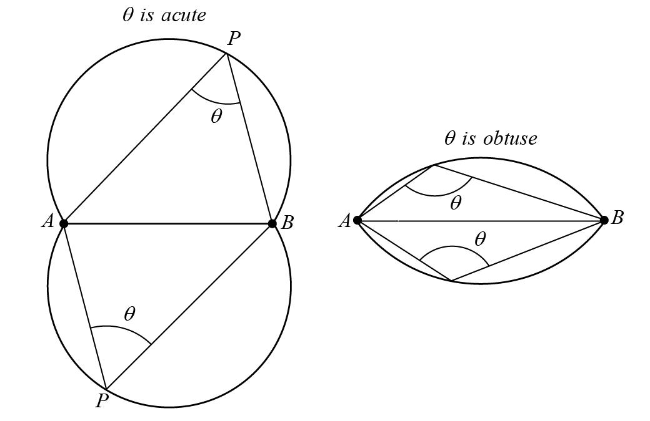
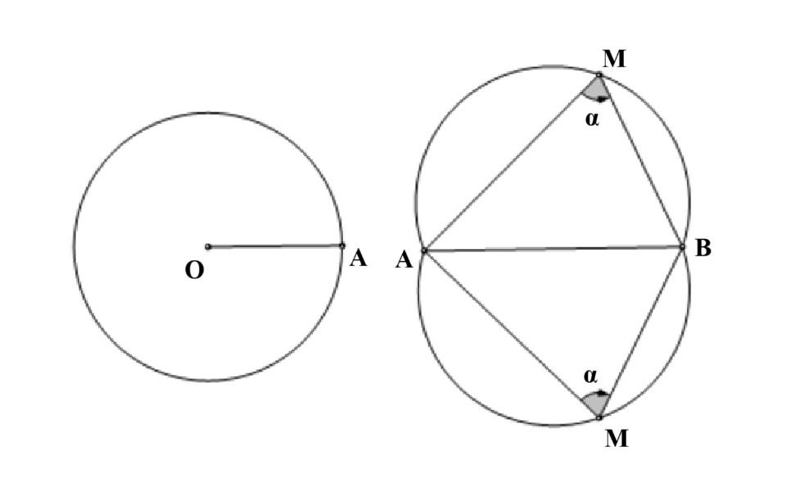
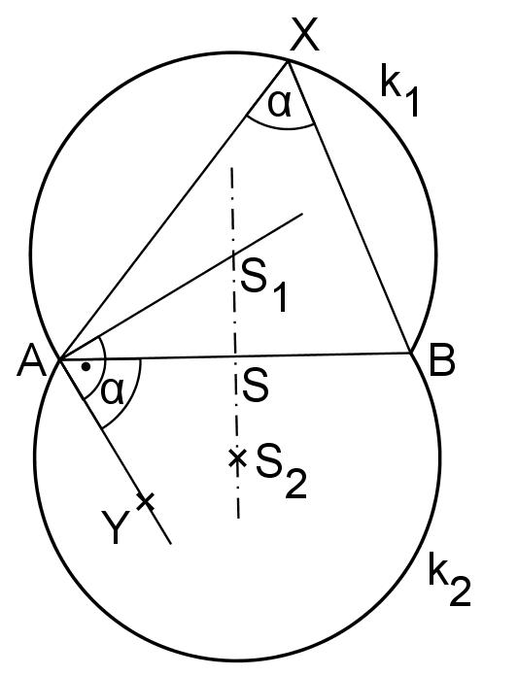

Simple Definition
# Source: AI Source: Provided by: [Data Path: Persons Table -> ID Column: 1, Name_En Column: Motasem Essam] -> From: [ChatGPT] on [7/25/2026]
A fixed-angle locus is the set of all points from which a fixed segment is viewed at the same constant angle.
For example, if $A$and $B$are fixed and every point $P$must satisfy
$$∠APB={60}^{∘},$$
then all possible positions of $P$lie on appropriate circular arcs through $A$and $B$.

Fundamental Concept
# Source: AI Source: Provided by: [Data Path: Persons Table -> ID Column: 1, Name_En Column: Motasem Essam] -> From: [ChatGPT] on [7/25/2026]
Suppose $A$and $B$are fixed points.
We want to find every point $P$such that
$$∠APB=θ.$$
The segment $AB$acts as a fixed chord of a circle.
By the Inscribed Angle Theorem, all inscribed angles subtending the same chord and lying on the same arc are equal.
Therefore, a fixed angle subtended by $AB$produces a circular arc.
$$\boxed{\text{Fixed Segment}+\text{Fixed Inscribed Angle}→\text{Circular Arc}}$$

Main Structure
# Source: AI Source: Provided by: [Data Path: Persons Table -> ID Column: 1, Name_En Column: Motasem Essam] -> From: [ChatGPT] on [7/25/2026]
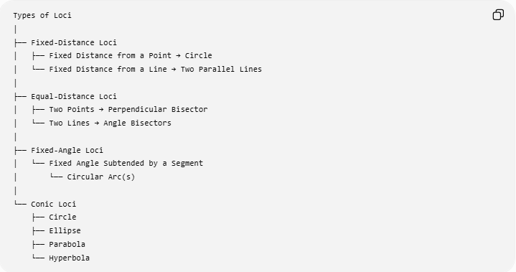
Types of Loci
│
├── Fixed-Distance Loci
│ ├── Fixed Distance from a Point → Circle
│ └── Fixed Distance from a Line → Two Parallel Lines
│
├── Equal-Distance Loci
│ ├── Two Points → Perpendicular Bisector
│ └── Two Lines → Angle Bisectors
│
├── Fixed-Angle Loci
│ └── Fixed Angle Subtended by a Segment
│ └── Circular Arc(s)
│
└── Conic Loci
├── Circle
├── Ellipse
├── Parabola
└── Hyperbola

Fixed Angle Subtended by a Segment
# Source: AI Source: Provided by: [Data Path: Persons Table -> ID Column: 1, Name_En Column: Motasem Essam] -> From: [ChatGPT] on [7/25/2026]
Let $A$and $B$be fixed points.
The condition is
$$\boxed{∠APB=θ}$$
for a constant angle $θ$.
The locus consists of points $P$lying on circular arcs through $A$and $B$.
Example
Suppose
$$AB=10$$
and we require
$$∠APB={30}^{∘}.$$
Every point $P$from which the segment $AB$subtends an angle of ${30}^{∘}$lies on the corresponding circular arc through $A$and $B$.
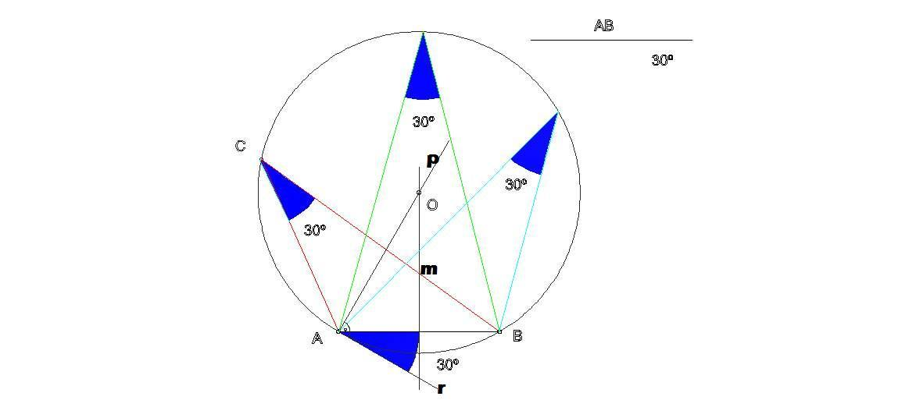
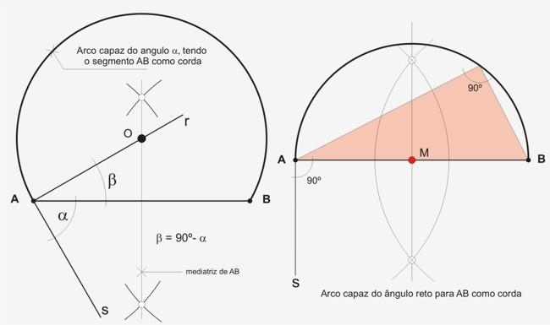
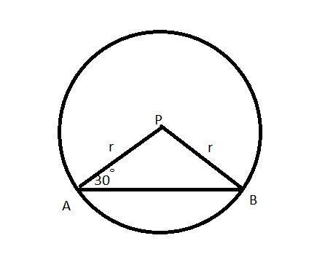

The Circular-Arc Locus
# Source: AI Source: Provided by: [Data Path: Persons Table -> ID Column: 1, Name_En Column: Motasem Essam] -> From: [ChatGPT] on [7/25/2026]
The most important result is:
$$\boxed{∠APB=θ ⇒ P\text{ lies on a circular arc through }A,B}$$
provided $A$and $B$are fixed and the angle is fixed.
The segment $AB$becomes a chord of the circle.
For a circle with radius $R$, if $AB$is the chord subtending the inscribed angle $θ$, then
$$AB=2R\sin{θ}.$$
Therefore,
$$\boxed{R=\frac{AB}{2\sin{θ}}}.$$
This gives the radius of the circle associated with the fixed-angle locus.
Example
Let
$$AB=10, θ={30}^{∘}.$$
Then
$$R=\frac{10}{2\sin{{30}^{∘}}} \\ R=\frac{10}{2\left(1/2\right)} \\ \boxed{R=10}.$$
So the relevant circle has radius $10$.

Fixed Angle of ${90}^{∘}$
# Source: AI Source: Provided by: [Data Path: Persons Table -> ID Column: 1, Name_En Column: Motasem Essam] -> From: [ChatGPT] on [7/25/2026]
The most important special case is
$$\boxed{∠APB={90}^{∘}}.$$
By Thales' Theorem, the locus of points $P$satisfying
$$∠APB={90}^{∘}$$
is the circle having $AB$as its diameter.
Thus,
$$\boxed{\text{Fixed right angle}→\text{Circle with }AB\text{ as diameter}}$$
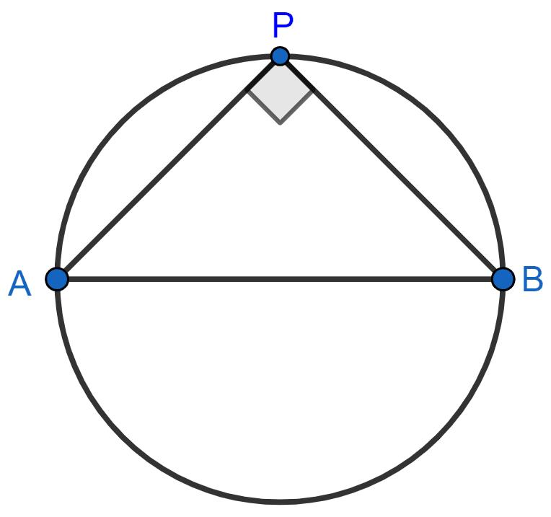
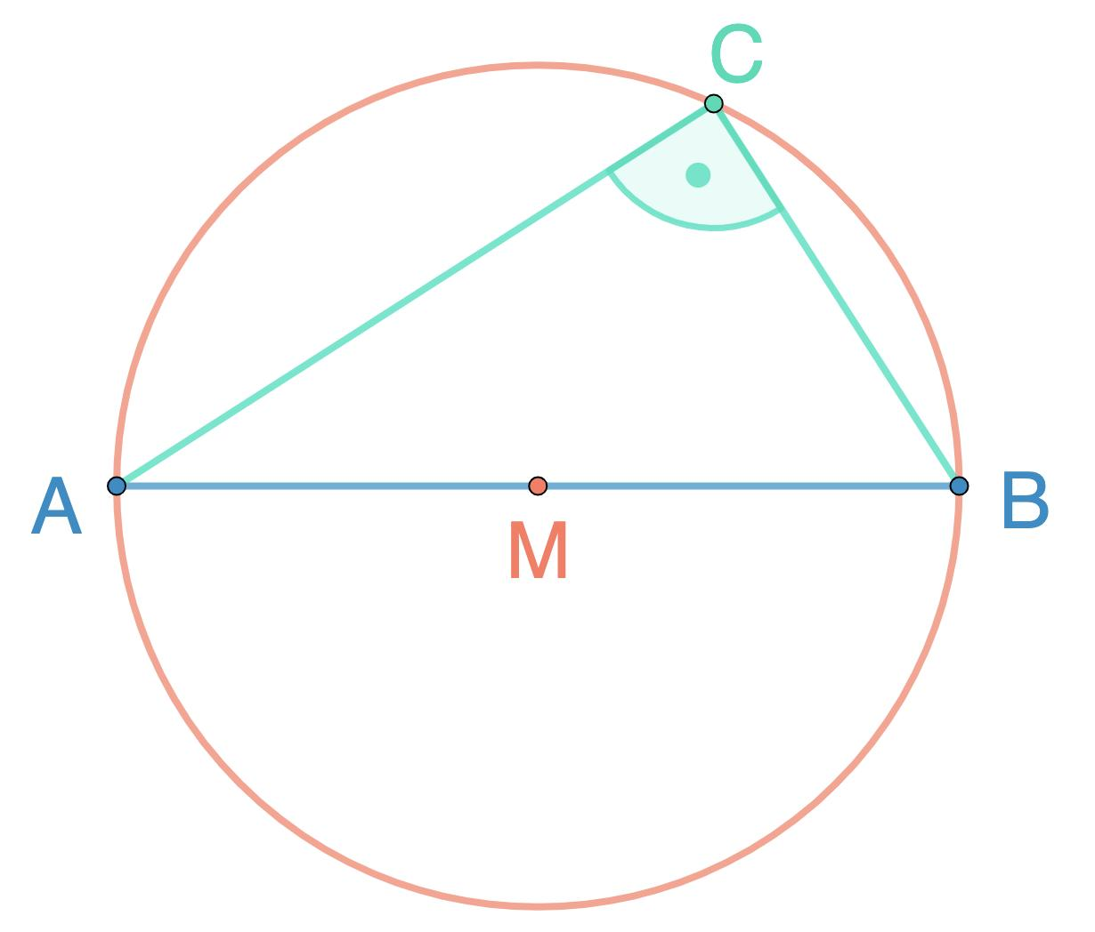
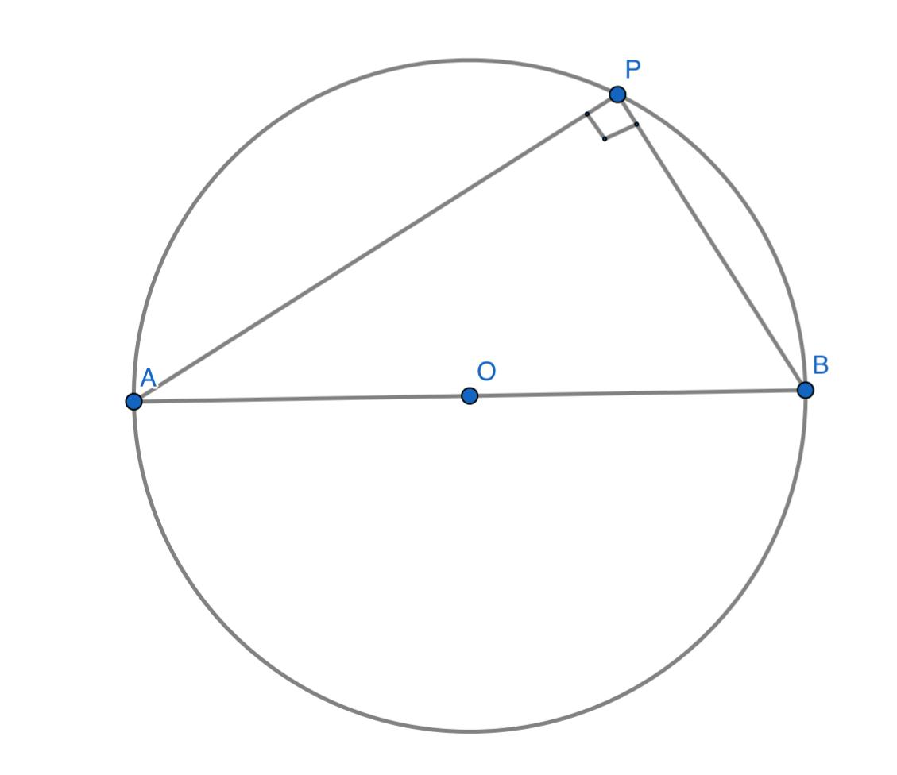
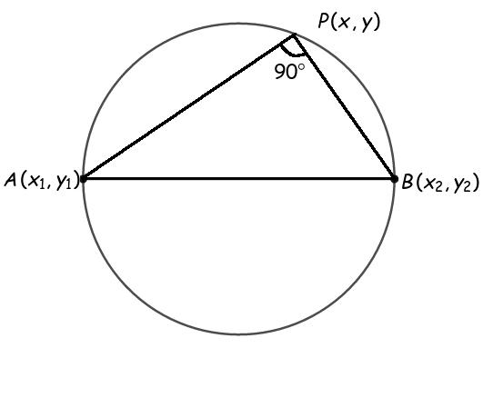
Example
Let
$$A=\left(0 , 0\right), B=\left(8 , 0\right).$$
The midpoint of $AB$is
$$M=\left(4 , 0\right).$$
The radius is
$$r=4.$$
Therefore, the circle is
$$\boxed{{\left(x-4\right)}^{2}+y^{2}=16}.$$
Every point $P$on this circle, except $A$and $B$, satisfies
$$∠APB={90}^{∘}.$$

Fixed Acute Angle
# Source: AI Source: Provided by: [Data Path: Persons Table -> ID Column: 1, Name_En Column: Motasem Essam] -> From: [ChatGPT] on [7/25/2026]
Suppose
$$0^{∘}<θ<{90}^{∘}.$$
Then the locus is a circular arc whose points see $AB$under the acute angle $θ$.
Using
$$R=\frac{AB}{2\sin{θ}},$$
we can determine the circle's radius.
Example
Let
$$AB=12, ∠APB={30}^{∘}.$$
Then
$$R=\frac{12}{2\sin{{30}^{∘}}} \\ R=\frac{12}{1}=12.$$
Thus, the corresponding circle has radius
$$\boxed{R=12}.$$
The center lies on the perpendicular bisector of $AB$.

Fixed Obtuse Angle
# Source: AI Source: Provided by: [Data Path: Persons Table -> ID Column: 1, Name_En Column: Motasem Essam] -> From: [ChatGPT] on [7/25/2026]
Suppose
$${90}^{∘}<θ<{180}^{∘}.$$
The same general relationship applies:
$$R=\frac{AB}{2\sin{θ}}.$$
Since
$$\sin{θ}=sin⁡\left({180}^{∘}-θ\right),$$
the same radius magnitude occurs for supplementary angles.
However, the relevant arc is different.
Example
If
$$∠APB={120}^{∘},$$
then
$$R=\frac{AB}{2\sin{{120}^{∘}}}.$$
Since
$$\sin{{120}^{∘}}=\frac{\sqrt{3}}{2},$$
we obtain
$$\boxed{R=\frac{AB}{\sqrt{3}}}.$$

Two Circular Arcs
# Source: AI Source: Provided by: [Data Path: Persons Table -> ID Column: 1, Name_En Column: Motasem Essam] -> From: [ChatGPT] on [7/25/2026]
There is an important geometric detail.
Because the fixed points $A$and $B$divide the plane into two sides, there can be corresponding loci on both sides of $AB$.
Thus, the complete unrestricted locus can be described as two symmetric circular arcs.
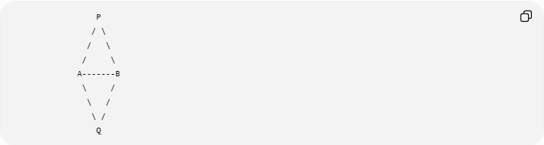
P
/ \
/ \
/ \
A-------B
\ /
\ /
\ /
Q
Both $P$and $Q$can satisfy
$$∠APB=∠AQB=θ$$
when the appropriate corresponding arcs are considered.

Relationship with the Perpendicular Bisector
# Source: AI Source: Provided by: [Data Path: Persons Table -> ID Column: 1, Name_En Column: Motasem Essam] -> From: [ChatGPT] on [7/25/2026]
The center $O$of the circle containing the fixed-angle locus lies on the perpendicular bisector of $AB$.
Therefore:
$$\boxed{OA=OB}$$
because $AB$is a chord of the circle.
If $M$is the midpoint of $AB$, then
$$OM⊥AB.$$
The geometry can therefore be constructed using:
- the fixed segment $AB$,
- its perpendicular bisector,
- the required angle $θ$,
- the corresponding circle center.
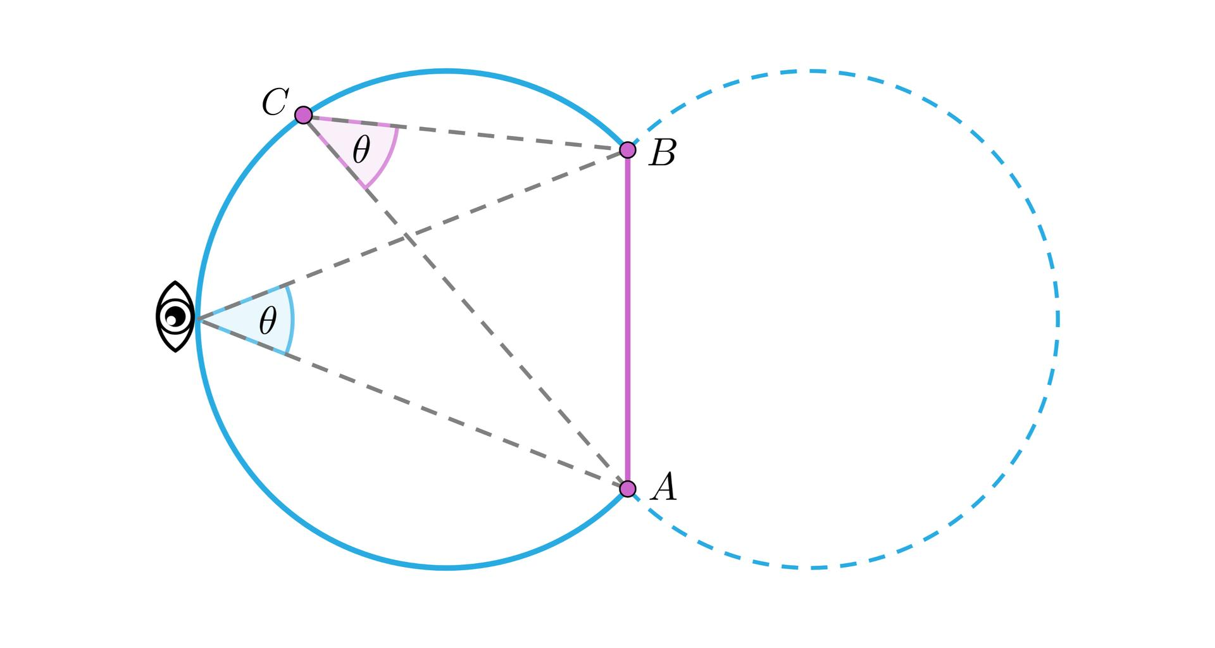
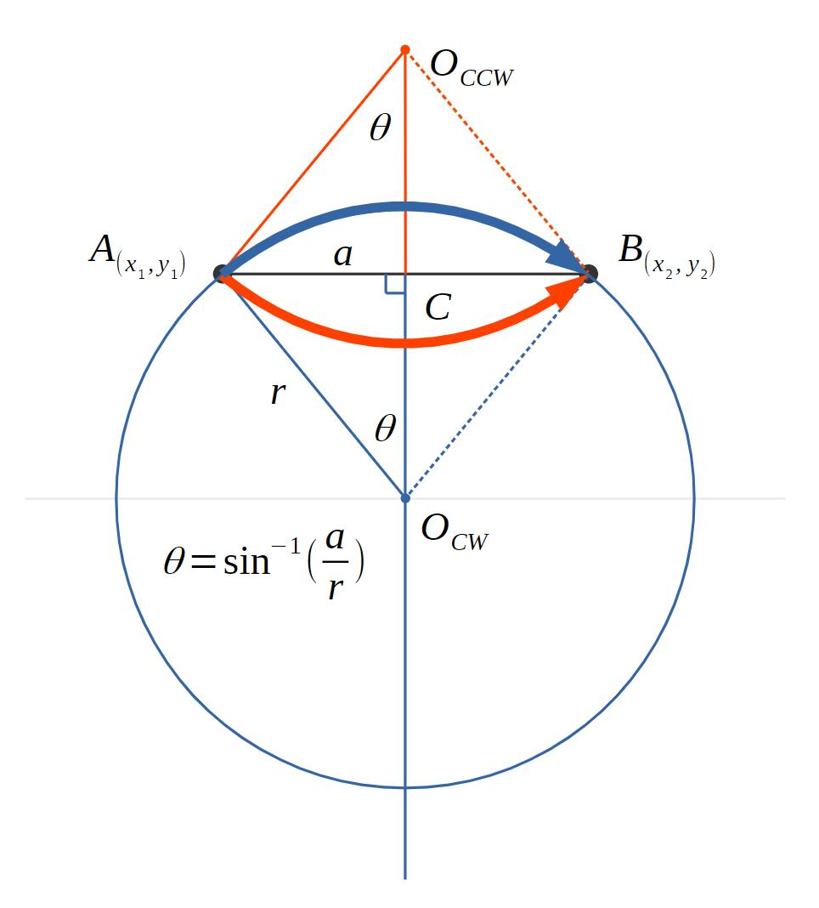
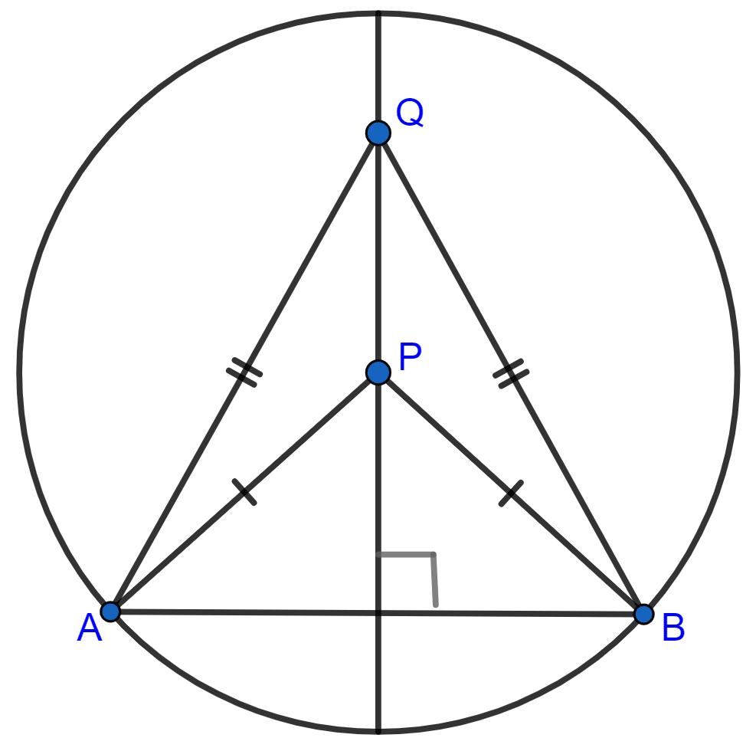

Relationship with the Inscribed Angle Theorem
# Source: AI Source: Provided by: [Data Path: Persons Table -> ID Column: 1, Name_En Column: Motasem Essam] -> From: [ChatGPT] on [7/25/2026]
The fixed-angle locus is fundamentally an application of the Inscribed Angle Theorem.
For a circle,
$$\boxed{m∠APB=\frac{1}{2}m\hat{AB}}$$
Therefore, if the intercepted arc $AB$is fixed, the inscribed angle is fixed.
Conversely, if the angle subtended by $AB$is fixed, the possible points $P$lie on the appropriate circular arc through $A$and $B$.
Thus:
$$\boxed{\text{Fixed Inscribed Angle}↔\text{Fixed Chord and Circular Arc}}$$

Coordinate Geometry Form
# Source: AI Source: Provided by: [Data Path: Persons Table -> ID Column: 1, Name_En Column: Motasem Essam] -> From: [ChatGPT] on [7/25/2026]
Suppose
$$A=\left(x_{1} , y_{1}\right), B=\left(x_{2} , y_{2}\right).$$
The condition
$$∠APB=θ$$
can be expressed using vectors:
$$\vec{PA}=A-P, \vec{PB}=B-P.$$
Then
$$\boxed{\cos{θ}=\frac{\vec{PA}⋅\vec{PB}}{∣\vec{PA}∣ ∣\vec{PB}∣}}$$
or
$$\boxed{\vec{PA}⋅\vec{PB}=∣\vec{PA}∣ ∣\vec{PB}∣\cos{θ}}.$$
This equation describes the fixed-angle condition.
For particular coordinates, it can be transformed into the equation of the corresponding circle or arcs.

Special Case: Angle ${90}^{∘}$
# Source: AI Source: Provided by: [Data Path: Persons Table -> ID Column: 1, Name_En Column: Motasem Essam] -> From: [ChatGPT] on [7/25/2026]
For
$$θ={90}^{∘},$$
we have
$$\cos{{90}^{∘}}=0.$$
Therefore,
$$\vec{PA}⋅\vec{PB}=0.$$
So
$$PA⊥PB.$$
This produces the circle with diameter $AB$, exactly as stated by Thales' Theorem.

Special Case: Angle ${60}^{∘}$
# Source: AI Source: Provided by: [Data Path: Persons Table -> ID Column: 1, Name_En Column: Motasem Essam] -> From: [ChatGPT] on [7/25/2026]
Suppose
$$∠APB={60}^{∘}.$$
Then
$$R=\frac{AB}{2\sin{{60}^{∘}}}.$$
Since
$$\sin{{60}^{∘}}=\frac{\sqrt{3}}{2},$$
we get
$$\boxed{R=\frac{AB}{\sqrt{3}}}.$$
Example
If
$$AB=6,$$
then
$$R=\frac{6}{\sqrt{3}}=2\sqrt{3}.$$
Thus the associated circle has radius
$$\boxed{2\sqrt{3}}.$$

Fixed Angle and Circular Segment
# Source: AI Source: Provided by: [Data Path: Persons Table -> ID Column: 1, Name_En Column: Motasem Essam] -> From: [ChatGPT] on [7/25/2026]
The locus should not usually be described as the entire circle.
The actual locus is the portion of the circle for which the required angle is obtained.
This distinction is important.
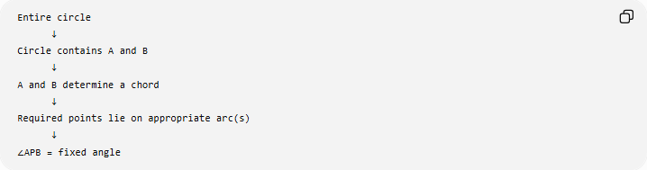
Entire circle
↓
Circle contains A and B
↓
A and B determine a chord
↓
Required points lie on appropriate arc(s)
↓
∠APB = fixed angle
So:
$$\boxed{\text{Fixed-angle locus}=\text{appropriate circular arc(s)}}$$
rather than simply “the whole circle.”

Example: Constructing the Locus
# Source: AI Source: Provided by: [Data Path: Persons Table -> ID Column: 1, Name_En Column: Motasem Essam] -> From: [ChatGPT] on [7/25/2026]
Problem
Given a fixed segment $AB$, construct the locus of points $P$satisfying
$$∠APB={45}^{∘}.$$
Construction idea
- Draw the fixed segment $AB$.
- Construct its perpendicular bisector.
- Determine the circle whose chord $AB$subtends an inscribed angle of ${45}^{∘}$.
- The center lies on the perpendicular bisector of $AB$.
- Draw the corresponding circle.
- Select the appropriate arcs through $A$and $B$.
The resulting arcs form the locus.

Example with a Fixed Segment
# Source: AI Source: Provided by: [Data Path: Persons Table -> ID Column: 1, Name_En Column: Motasem Essam] -> From: [ChatGPT] on [7/25/2026]
Let
$$AB=20$$
and
$$∠APB={30}^{∘}.$$
Using
$$R=\frac{AB}{2\sin{{30}^{∘}}},$$
we obtain
$$R=\frac{20}{2\left(1/2\right)} \\ \boxed{R=20}.$$
Therefore, the relevant circular arcs have radius $20$.
Every appropriate point $P$on the locus satisfies
$$\boxed{∠APB={30}^{∘}}.$$

Fixed Angle vs Fixed Distance
# Source: AI Source: Provided by: [Data Path: Persons Table -> ID Column: 1, Name_En Column: Motasem Essam] -> From: [ChatGPT] on [7/25/2026]
These are different types of loci.
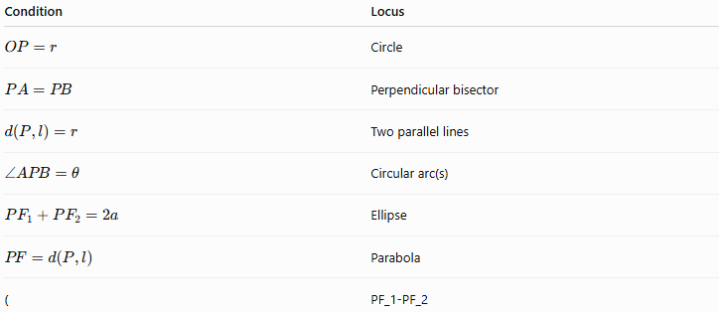
Condition | Locus
$$OP=r$$ | Circle
$$PA=PB$$ | Perpendicular bisector
$$d\left(P , l\right)=r$$ | Two parallel lines
$$∠APB=θ$$ | Circular arc(s)
$$PF_{1}+PF_{2}=2a$$ | Ellipse
$$PF=d\left(P , l\right)$$ | Parabola
( | PF_1-PF_2
The fixed-angle locus is therefore an angle-defined locus, while the circle itself is a distance-defined object.

Fixed Angle vs Equidistant from Two Lines
# Source: AI Source: Provided by: [Data Path: Persons Table -> ID Column: 1, Name_En Column: Motasem Essam] -> From: [ChatGPT] on [7/25/2026]
These can look similar but represent different conditions.
Equidistant from two lines
$$d\left(P , l_{1}\right)=d\left(P , l_{2}\right)$$
produces angle bisectors.
Fixed angle subtended by two points
$$∠APB=θ$$
produces circular arcs.
Therefore:
$$\boxed{\text{Equal distances from lines}→\text{Angle Bisectors}}$$
but
$$\boxed{\text{Fixed angle between }PA\text{ and }PB→\text{Circular Arc}}$$

Important Special Cases
# Source: AI Source: Provided by: [Data Path: Persons Table -> ID Column: 1, Name_En Column: Motasem Essam] -> From: [ChatGPT] on [7/25/2026]
$$0^{∘}<θ<{90}^{∘}$$
The locus corresponds to an acute angle.
$$θ={90}^{∘}$$
The locus is the circle with $AB$as diameter.
$$\boxed{∠APB={90}^{∘}}$$
$${90}^{∘}<θ<{180}^{∘}$$
The locus corresponds to an obtuse angle on the appropriate arc.
$$θ={180}^{∘}$$
The points become collinear with $A$and $B$, so this is a degenerate limiting case rather than an ordinary circular-arc locus.
$$θ=0^{∘}$$
This is also degenerate: $A,P,B$become aligned in the limiting configuration.
Thus, the ordinary fixed-angle locus is normally considered for
$$\boxed{0^{∘}<θ<{180}^{∘}}.$$

Important Geometric Relationship
# Source: AI Source: Provided by: [Data Path: Persons Table -> ID Column: 1, Name_En Column: Motasem Essam] -> From: [ChatGPT] on [7/25/2026]
If $AB$is a chord of a circle and $P$moves along the same appropriate arc, then
$$∠APB$$
remains constant.
This is a direct consequence of the Inscribed Angle Theorem.
Therefore, a moving point can travel along the locus without changing the angle.
$$\boxed{P\text{ moves along the arc}⇒∠APB=\text{constant}}$$

Classification
# Source: AI Source: Provided by: [Data Path: Persons Table -> ID Column: 1, Name_En Column: Motasem Essam] -> From: [ChatGPT] on [7/25/2026]
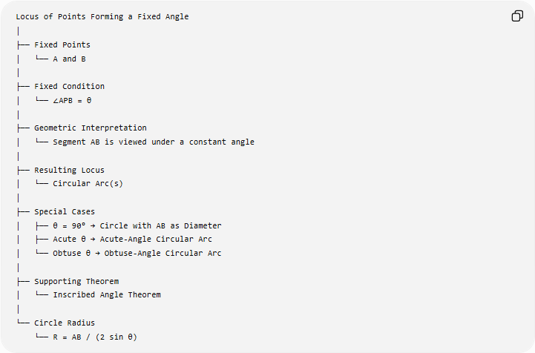
Locus of Points Forming a Fixed Angle
│
├── Fixed Points
│ └── A and B
│
├── Fixed Condition
│ └── ∠APB = θ
│
├── Geometric Interpretation
│ └── Segment AB is viewed under a constant angle
│
├── Resulting Locus
│ └── Circular Arc(s)
│
├── Special Cases
│ ├── θ = 90° → Circle with AB as Diameter
│ ├── Acute θ → Acute-Angle Circular Arc
│ └── Obtuse θ → Obtuse-Angle Circular Arc
│
├── Supporting Theorem
│ └── Inscribed Angle Theorem
│
└── Circle Radius
└── R = AB / (2 sin θ)

Key Formulas
# Source: AI Source: Provided by: [Data Path: Persons Table -> ID Column: 1, Name_En Column: Motasem Essam] -> From: [ChatGPT] on [7/25/2026]
Fixed-angle condition
$$\boxed{∠APB=θ}$$
Radius of the associated circle
$$\boxed{R=\frac{AB}{2\sin{θ}}}$$
Chord-length formula
$$\boxed{AB=2R\sin{θ}}$$
Inscribed-angle theorem
$$\boxed{m∠APB=\frac{1}{2}m\hat{AB}}$$
Right-angle special case
$$\boxed{∠APB={90}^{∘}⇒AB\text{ is a diameter}}$$

Important Distinction
# Source: AI Source: Provided by: [Data Path: Persons Table -> ID Column: 1, Name_En Column: Motasem Essam] -> From: [ChatGPT] on [7/25/2026]
A fixed-angle locus is not simply “a circle.”
More precisely:
$$\boxed{\text{Fixed angle subtended by a fixed segment}→\text{appropriate circular arc(s)}}$$
The circle is the geometric curve containing the locus, while the actual locus may be only a particular arc or arcs depending on the required angle and the allowed region.

Classification Summary
# Source: AI Source: Provided by: [Data Path: Persons Table -> ID Column: 1, Name_En Column: Motasem Essam] -> From: [ChatGPT] on [7/25/2026]
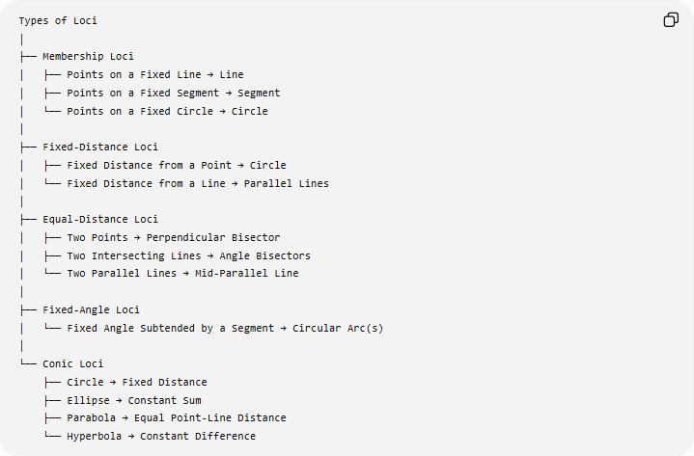
Types of Loci
│
├── Membership Loci
│ ├── Points on a Fixed Line → Line
│ ├── Points on a Fixed Segment → Segment
│ └── Points on a Fixed Circle → Circle
│
├── Fixed-Distance Loci
│ ├── Fixed Distance from a Point → Circle
│ └── Fixed Distance from a Line → Parallel Lines
│
├── Equal-Distance Loci
│ ├── Two Points → Perpendicular Bisector
│ ├── Two Intersecting Lines → Angle Bisectors
│ └── Two Parallel Lines → Mid-Parallel Line
│
├── Fixed-Angle Loci
│ └── Fixed Angle Subtended by a Segment → Circular Arc(s)
│
└── Conic Loci
├── Circle → Fixed Distance
├── Ellipse → Constant Sum
├── Parabola → Equal Point-Line Distance
└── Hyperbola → Constant Difference

Key Points
# Source: AI Source: Provided by: [Data Path: Persons Table -> ID Column: 1, Name_En Column: Motasem Essam] -> From: [ChatGPT] on [7/25/2026]
- A fixed-angle locus involves two fixed points $A,B$.
- The moving point $P$satisfies
$$∠APB=θ.$$
- The locus is generally a circular arc or arcs through $A$and $B$.
- The result follows from the Inscribed Angle Theorem.
- The associated circle has radius
$$R=\frac{AB}{2\sin{θ}}.$$
- For ${90}^{∘}$, the locus is the circle with $AB$as its diameter.
- The center of the associated circle lies on the perpendicular bisector of $AB$.
- The complete locus depends on whether the problem restricts $P$to a particular side or region.
- This is different from an equal-distance locus, which produces perpendicular bisectors or angle bisectors.

Conclusion
# Source: AI Source: Provided by: [Data Path: Persons Table -> ID Column: 1, Name_En Column: Motasem Essam] -> From: [ChatGPT] on [7/25/2026]
The Locus of Points Forming a Fixed Angle is an important angle-based locus. Given two fixed points $A$and $B$, all points $P$satisfying
$$\boxed{∠APB=θ}$$
lie on appropriate circular arcs through $A$and $B$. The fundamental reason is that equal inscribed angles subtending the same chord correspond to points on the same circular arc.
The central relationship is:
$$\boxed{\text{Fixed Segment}+\text{Fixed Subtended Angle}→\text{Circular Arc Locus}}$$
with
$$\boxed{R=\frac{AB}{2\sin{θ}}}$$
and the especially important case
$$\boxed{θ={90}^{∘}→\text{Circle with }AB\text{ as Diameter}.}$$

